ATTACHMENT A
INSTRUCTIONS FOR OBTAINING AN Unique Entity ID (SAM)
DAI’S VENDORS, SUBCONTRACTORS & GRANTEES
Note: There is a Mandatory Requirement for your Organization to Provide an Unique Entity ID (SAM) to DAI
I. SUBCONTRACTS/PURCHASE ORDERS: All domestic and foreign organizations which receive first-tier subcontracts/ purchase orders with a value of $30,000 and above are required to obtain an Unique Entity ID (SAM) prior to signing of the agreement. Your organization is exempt from this requirement if the gross income received from all sources in the previous tax year was under $300,000. Please see the self-certification form attached.
II. MONETARY GRANTS: All foreign entities receiving first-tier monetary grants (standard, simplified and FOGs) with a value equal to or over $25,000 and performing work outside the U.S. must obtain an Unique Entity ID (SAM) prior to signing of the grant. All U.S. organizations who are recipients of first-tier monetary grants of any value are required to obtain an Unique Entity ID (SAM); the exemption for under $25,000 applies to foreign organizations only.
NO SUBCONTRACTS/POs ($30,000 + above) or MONETARY GRANTS WILL BE SIGNED BY DAI WITHOUT PRIOR RECEIPT OF AN UNIQUE ENTITY ID (SAM).

Note: The determination of a successful offeror/applicant resulting from this RFP/RFQ/RFA is contingent upon the winner providing an Unique Entity ID (SAM)to DAI. Organizations who fail to provide an Unique Entity ID (SAM) will not receive an award and DAI will select an alternate vendor/subcontractor/grantee.
--------------------------------------------------------------------------------------------------------------------------
Background:
Summary of Current U.S. Government Requirements - Unique Entity ID (SAM)
Effective April 4, 2022, entities doing business with the federal government will use the Unique Entity Identifier (SAM) created in SAM.gov. The Unique Entity ID (SAM) is a 12-character alphanumeric value managed, granted, and owned by the government. This allows the government to streamline the entity identification and validation process, making it easier and less burdensome for entities to do business with the federal government.

Entities are assigned an identifier during registration or one can be requested at SAM.gov without needing to register. Ernst and Young provides the validation services for the U.S. Government. The information required for getting an Unique Entity ID (SAM) without registration is minimal. It only validates your organization's legal business name and address. It is a verification that your organization is what you say it is.

The Unique Entity ID (SAM) does not expire.

Summary of Previous U.S. Government Requirements – DUNS

The Data Universal Numbering System (DUNS) is a system developed and managed by Dun and Bradstreet that assigns a unique nine-digit identifier to a business entity. It is a common standard world-wide and was previously used by the U.S. Government to assign unique entity identifiers. This system was retired by the U.S. Government on April 4, 2022 and replaced with the Unique Entity Identifier (SAM). After April 4, 2022 the federal government will have no requirements for the DUNS number.

If the entity was registered in SAM.gov (active or inactive registration), an Unique Entity ID (SAM) was assigned and viewable in the entity registration record in SAM.gov prior to the April 4, 2022 transition. The Unique Entity ID (SAM) can be found by signing into SAM.gov and selecting the Entity Management widget in your Workspace or by signing in and searching entity information.

Instructions detailing the process to be followed in order to obtain an Unique Entity ID (SAM) for your organization begin on the next page.
THE PROCESS FOR OBTAINING AN Unique Entity ID IS OUTLINED BELOW:
- Have the following information ready to request an Unique Entity ID (SAM)
  - Legal Business Name
  - Physical Address (including ZIP + 4)
  - SAM.gov account (this is a user account, not actual SAM.gov business registration).
    - As a new user, to get a SAM.gov account, go to www.sam.gov.
      - Click “Sign In” on the upper right hand corner.
      - Click on “Create a User Account”
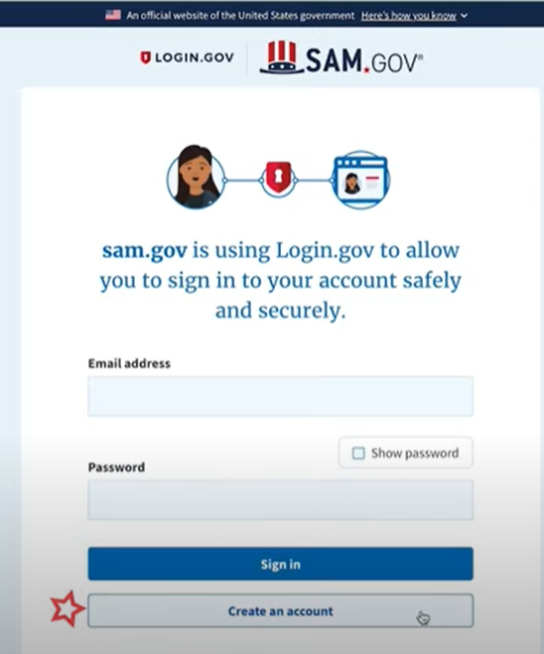
      - Choose Account Type:
        - Create an Individual User Account to perform tasks such as register/update your entity, create and manage exclusion records or to view FOUO level data for entity records.
        - Create a System User Account if you need system-to-system communication or if performing data transfer from SAM to your government database system. Complete the requested information, and then click “Submit.”
      - Click “DONE” on the confirmation page. You will receive an email confirming you have created a user account in SAM.
      - Click the validation link in the email that contains the activation code within 48 hours to activate your user account. If the email link is not hyperlinked (i.e., underlined or appearing in a different color), please copy the validation link and paste it into the browser address bar. You can now register an entity.
NOTE: Creating a user account does not create a registration in SAM, nor will it update/renew an existing registration in SAM.
- Once you have registered as a user, you can get an Unique Entity ID by selecting the “Get Started” button on the SAM.gov home page.
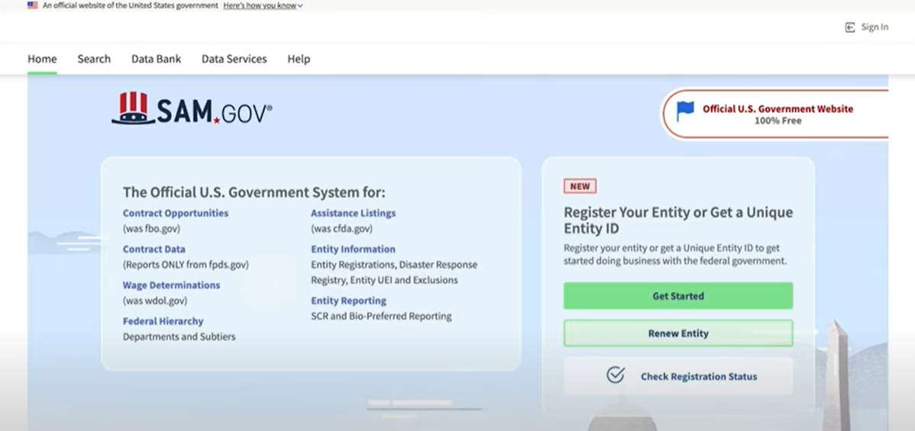

- Select “Get Started” on the Getting Started with Registration page.
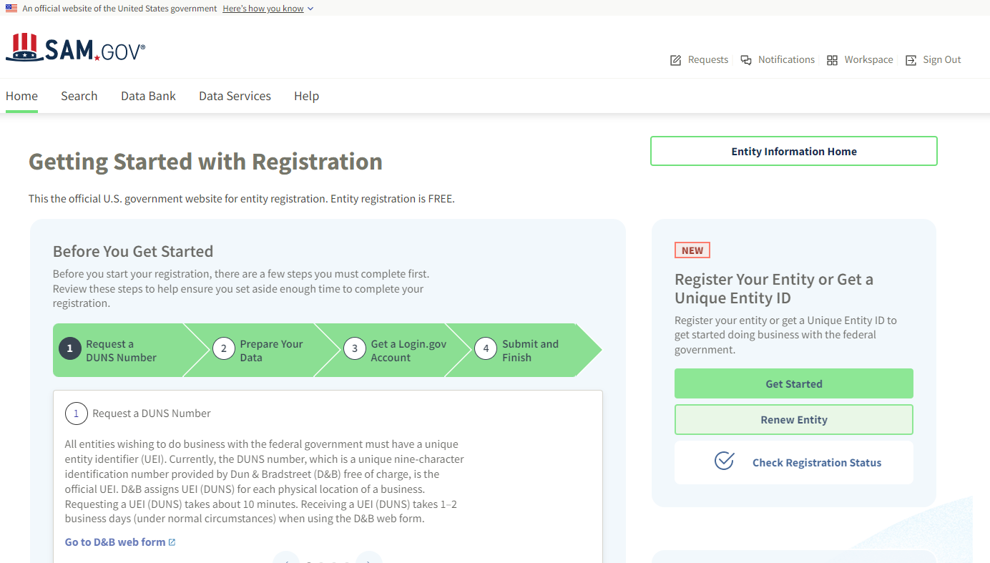

- Select “Get Unique Entity ID” on the Get Started page.
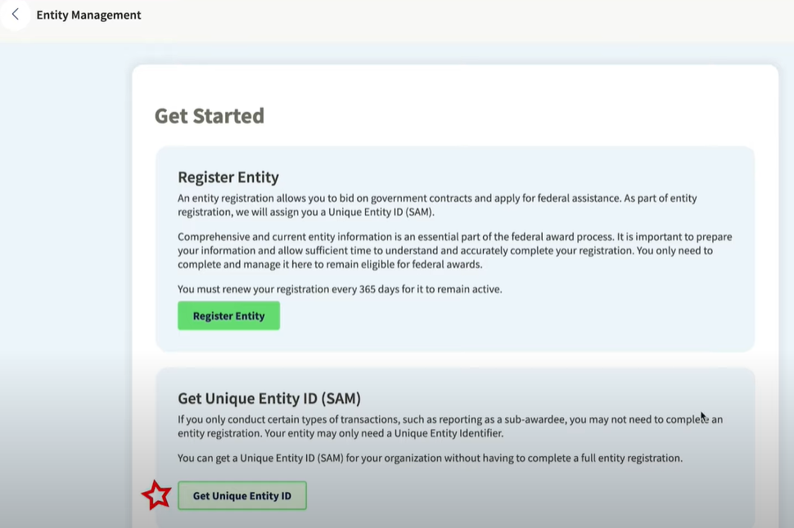
- Enter Entity Information.
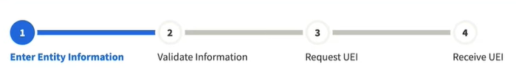
  - If you previously had a DUN Number, make sure your Legal Business Name and Physical Address are accurate and match the Entity Information, down to capitalization and punctuation, used for DUNS registration.
- When you are ready, select “Next”
- Confirm your company’s information.
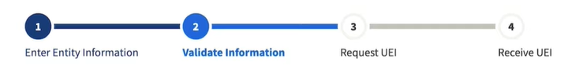
  - On this page you will have the option to restrict the public search of this information. “Allow the selected record to be a public display record.” If you uncheck this box, only you and the federal government users will be able to search and view the entity information and entities like DAI will not be able to independently verify that you have an Unique Entity Identifier (SAM).
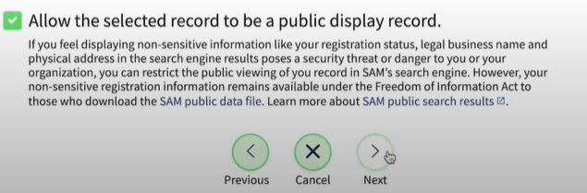
- When you are ready, select “Next”
- Once validation is completed, select “Request UEI” to be assigned an Unique Entity ID (SAM). Before requesting your UEI (SAM), you must certify that you are authorized to conduct transactions under penalty of law to reduce the likelihood of unauthorized transactions conducted for the entity.
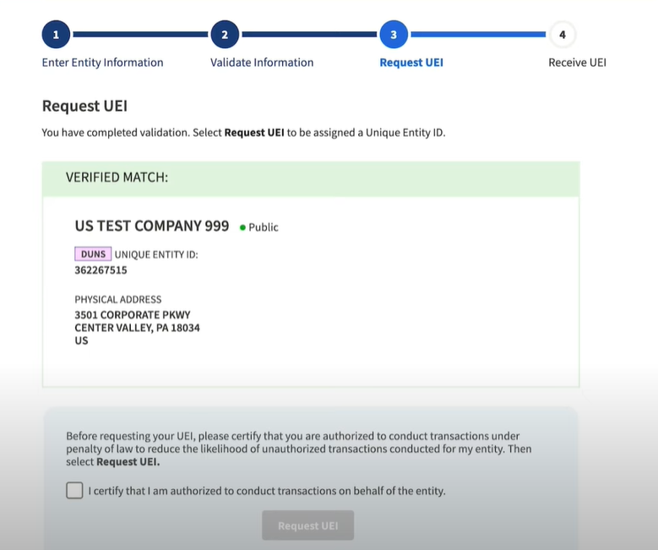
- The Unique Entity ID will be shown on the next page. SAM.gov will send an email confirmation with your Unique Entity ID.
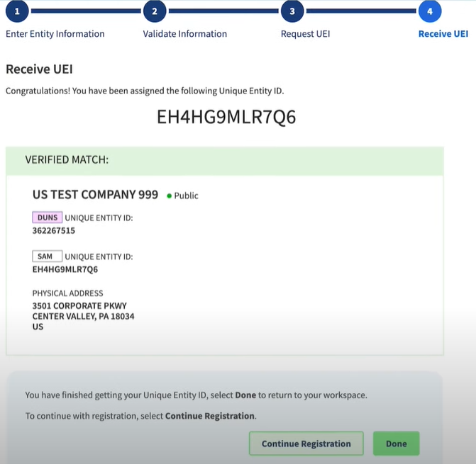
- If you need to view the Unique Entity ID from SAM in the future or update the organization’s information, sign into SAM.gov and go to “Entity Management” widget.
